**Prepared by: Sanyaolu Olubukola**

**Date: December 7, 2024**

**Introduction**

The purpose of this report is to provide a comprehensive analysis of the global internet user trends and cellular/broadband subscription patterns between 1980 and 2020. This analysis highlights critical insights, offers actionable recommendations, and discusses the implications of the findings on decision-making and potential areas for further investigation.

**Insights and Recommendations**

**1. Internet User Growth (1980–2020)**

* **Insight:**
  + Global internet users grew exponentially from less than 0.1 billion in 1980 to 9.6 billion in 2020. The growth was particularly notable from 2010 to 2020, where user count almost doubled.

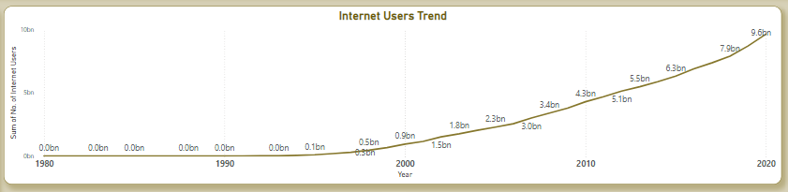

* **Decision Implications:**
  + Governments and tech companies must ensure infrastructure scalability to sustain such rapid growth.
  + Businesses should identify emerging internet markets for product launches and digital service delivery.
* **Further Investigation:**
  + Investigate key drivers behind rapid growth in the 2010s, including technological advancements, affordability, and government policies.
  + Analyze growth patterns in specific regions or demographics.

**2. Top Internet-Using Countries**

* **Insight:**
  + China is the largest contributor with 9 billion users, followed by North America (7 billion), the United States (5 billion), and India (3 billion).

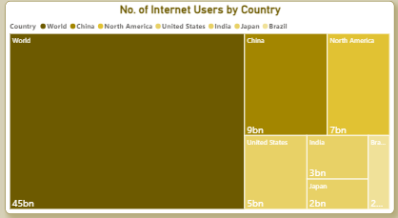

* **Decision Implications:**
  + Businesses should focus on China and North America for market expansion due to their large user bases.
  + Policymakers in countries with lower user counts can prioritize digital access initiatives.
* **Further Investigation:**
  + Study factors influencing high user counts in China and North America, such as government policies, economic factors, or population size.
  + Analyze the digital divide within countries to identify underserved populations.

**3. Cellular Subscriptions by Country**

* **Insight:**
  + Countries like Macao (4.7K subscriptions) and Hong Kong (4.2K) lead in cellular penetration, followed by the UAE, Italy, and others.

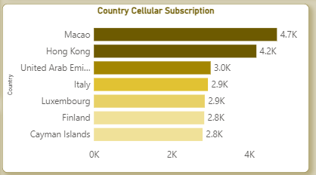

* **Decision Implications:**
  + Telecom companies should prioritize mobile-first strategies in these regions, such as launching 5G networks and mobile-based services.
  + Governments can use mobile penetration to promote e-governance and digital services.
* **Further Investigation:**
  + Analyze how cellular penetration correlates with internet access and economic growth.
  + Study challenges in maintaining quality of service with increasing subscriptions.

**4. Broadband Subscriptions by Country**

* **Insight:**
  + Monaco leads in broadband penetration with 765 subscriptions, followed by South Korea (674), Liechtenstein (670), and others.

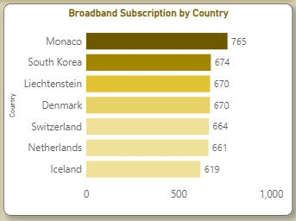

* **Decision Implications:**
  + Countries with strong broadband infrastructure, such as Monaco , South Korea, can be models for others aiming to enhance fixed-line internet services.
  + ISPs in developing regions can focus on affordability and infrastructure development to bridge the gap.
* **Further Investigation:**
  + Study the impact of broadband access on education, healthcare, and economic productivity in leading countries.
  + Assess infrastructure challenges in regions with low broadband adoption.

**5. Percentage of Population with Internet Access**

* **Insight:**
  + Countries like Iceland, Norway, Sweden, Denmark have high percentages of their population with internet access.

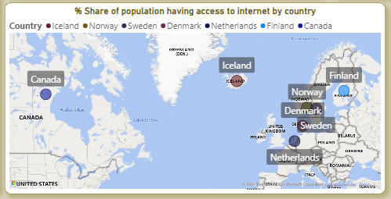

* **Decision Implications:**
  + Regions with high internet access rates can focus on advanced digital solutions, such as smart cities, IoT, and AI-driven platforms.
  + Policymakers in regions with low access rates should prioritize affordability and infrastructure investment.
* **Further Investigation:**
  + Analyze policy differences between countries with high and low internet access rates.
  + Study how digital literacy initiatives influence access rates in developing regions.

**6. Global Summary Metrics**

* **Insight:**
  + Total sum of internet users (151.13K in sampled data) and cellular subscriptions (354.59K) indicates robust global digital engagement.
* **Decision Implications:**
  + Regional organizations can use these figures to benchmark progress and allocate resources for underserved areas.
  + Telecom providers can use these insights to plan network upgrades and expansions.
* **Further Investigation:**
  + Assess the accuracy and coverage of the data sample.
  + Analyze specific regions contributing disproportionately to these metrics.

**Strategic Recommendations**

1. **Invest in Emerging Markets:**
   * Regions with low internet penetration (e.g., parts of Africa, South Asia) offer significant growth potential. Telecom providers and governments can collaborate to build infrastructure and promote affordable internet access.
2. **Enhance Mobile-First Strategies:**
   * With high mobile penetration in Macao, Hong Kong, and UAE, businesses should focus on mobile-driven services like mobile banking, e-commerce, and streaming platforms.
3. **Strengthen Broadband Access:**
   * In regions lagging behind, governments should prioritize broadband expansion by leveraging lessons from leaders like Monaco and South Korea.
4. **Promote Digital Inclusion:**
   * Governments and NGOs must focus on digital literacy programs to close the digital divide and ensure equitable access to the internet.
5. **Monitor User Trends for Business Opportunities:**
   * Businesses should leverage data on rapidly growing user bases (e.g., India, Brazil) to enter emerging markets with localized solutions.

**Conclusion**

The dashboard analysis underscores the remarkable global growth of internet users, varying degrees of digital adoption, and the potential for further development in emerging regions. Policymakers, businesses, and ISPs can leverage these insights to make informed decisions and foster inclusive digital transformation globally. Further investigations into specific regions and demographics will help refine strategies and ensure sustainable growth in internet access worldwide.